**Daily Scrum or Standup Meeting**

Team name: Alpha Squad

Scrum Master: Isaak Johnson

Date: Nov 15

|  |  |  |  |
| --- | --- | --- | --- |
| **Team Member** | **What did you do since the last scrum?** | **What do you plan to do before the next scrum?** | **What obstacles do you have?** |
| Alex Beeston | Learned about unit testing in Django | Write my unit tests | I still need to learn how to write unit tests correctly. |
| Joey Carlisle | Worked on tests just a little bit | work on testing more | just being busy |
| Isaak Johnson | Researched more about unit tests and attempted to implement one | finish all unit tests | getting None context |
| Ben Taylor | Wrote unit tests for the users and payment views. Updated the init function to have winning bids and items. Put won live items on payment page. Put auction total winnings on admin home page. | Finish putting user bid amount and won amounts on the different pages. | Need some way to know when a user has won silent items |

# Burndown

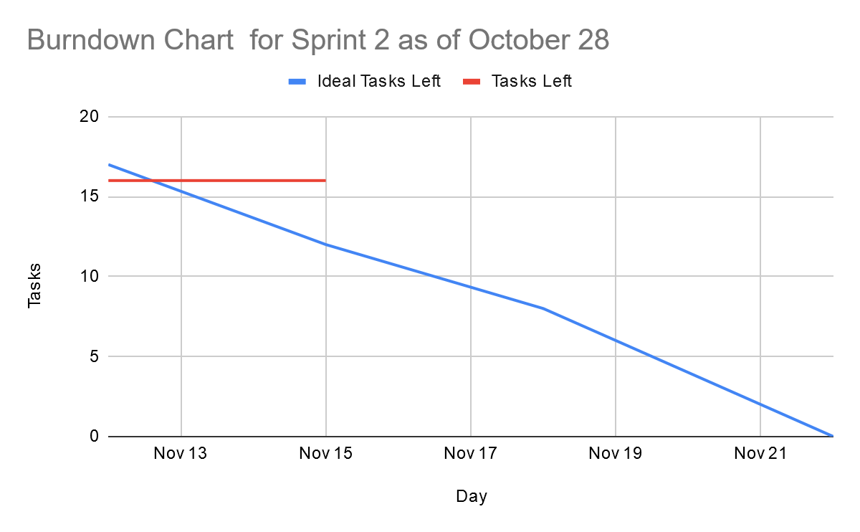

# Screenshot of you project board

